s
NAME: BISMA FATIMA
CLASS: CS A
ROLL NO: F24605036
COURSE: INFORMATION SECURITY
COURSE CODE: CS-291
LECTURER: MISS ATTIA ASHRAF

LAB 07

Part 1: Installation
Installing Node.js and NPM
Node.js and NPM are pre-requisites.
∙ As always, start with updating package lists.
sudo apt update
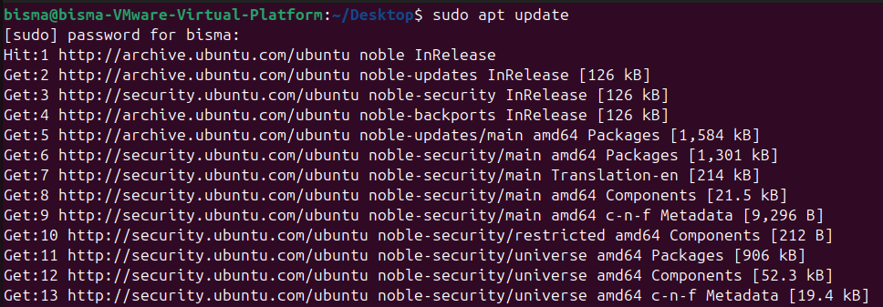
. install
Sudo apt install -y curl
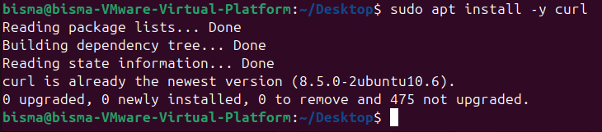
∙ To ensure you install Node.js v18, add the NodeSource repository:
curl -fsSL https://deb.nodesource.com/setup_18.x | sudo -E bash –
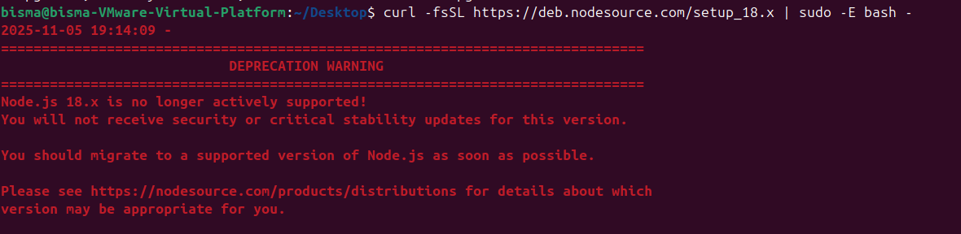
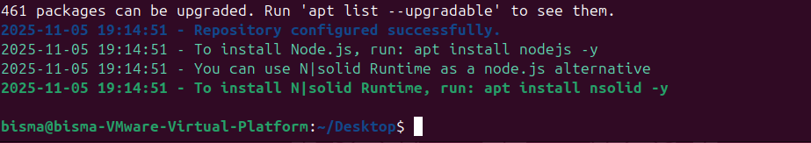
∙ After adding the repository, install Node.js and npm:
sudo apt install -y nodejs
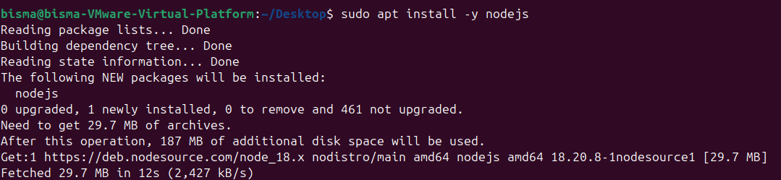
∙ Press Y when prompted to confirm installation. Check that the install was successful by querying node for its version number:
node -v && npm -v
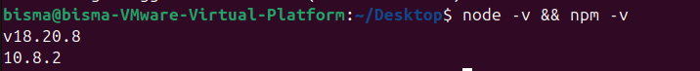
This installs node.js version 18.20 and NPM version 10.7.
Installing Juice Shop
OWASP Juice Shop is a deliberately vulnerable web application created by the Open Web Application Security Project (OWASP) for security education. It simulates an e-commerce platform, with real-world vulnerabilities that align with the OWASP Top Ten list, including SQL Injection, Cross-Site Scripting (XSS), and Broken Authentication.
By interacting with Juice Shop, students learn to:
1. Identify security weaknesses and understand the impact of vulnerabilities on application and database security.
2. Practice using security testing tools like OWASP ZAP to scan and exploit vulnerabilities. 3. Explore common security risks in a real-world context, with practical applications for securing modern web applications.
The steps to install Juice Shop are given below.
∙ Install git to clone Github repositories.
sudo apt install -y git
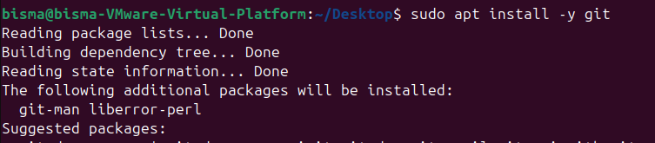
∙ Run the following command to clone into Juice Shop.
git clone https://github.com/juice-shop/juice-shop.git --depth 1
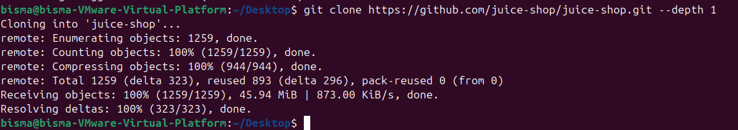∙ Go into the cloned folder and install the application.
cd juice-shop
npm install
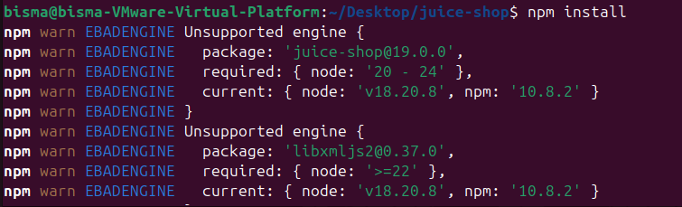
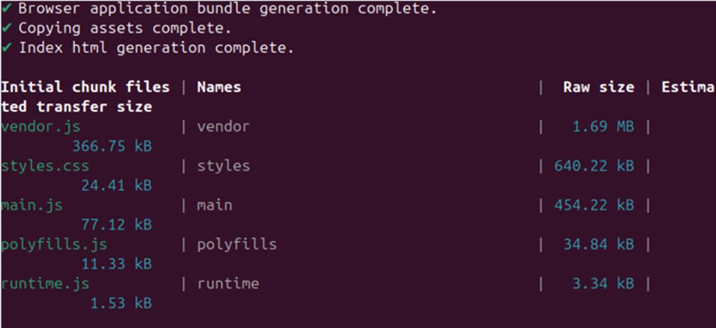
∙ Once installed, start with the following command:
npm start
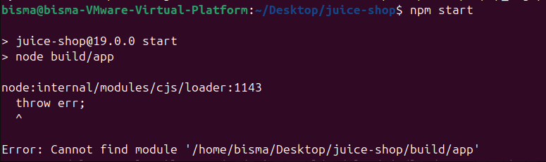 ∙ This application is running on port 3000. You can scan the ports using nmap.
nmap localhost
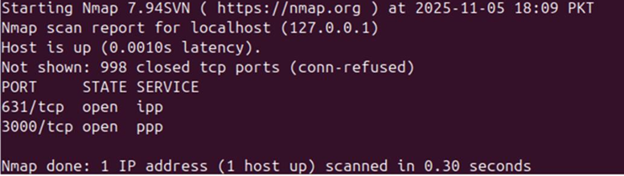
∙ This shows that port 3000 is open for tcp connections.
∙ Open the browser and browse http://localhost:3000
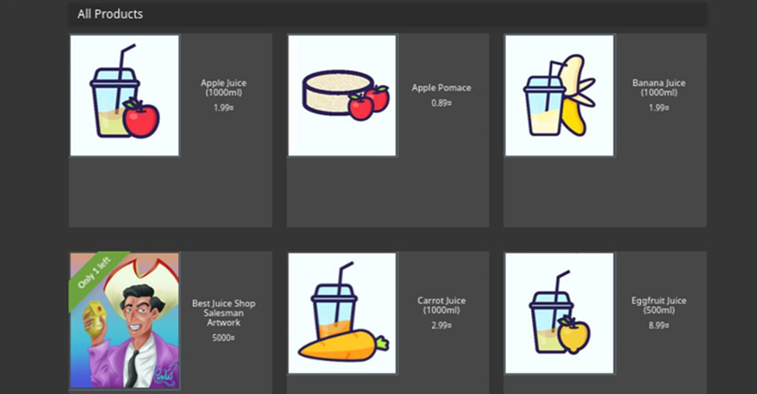
Analysis:
- --depth 1 clones only the most recent commit, optimizing for speed and disk usage.
- Running npm install fetches over 2000 dependencies; warnings during this process are expected and typically harmless.
- Executing npm start launches the Express.js server, which listens on port 3000.
- Outcome: A purposely insecure application is now set up and ready for security testing.
Installing and Setting up Zap
∙ Run the following command to install Zaproxy:
sudo snap install zaproxy --classic
∙ Run Zap
Zaproxy
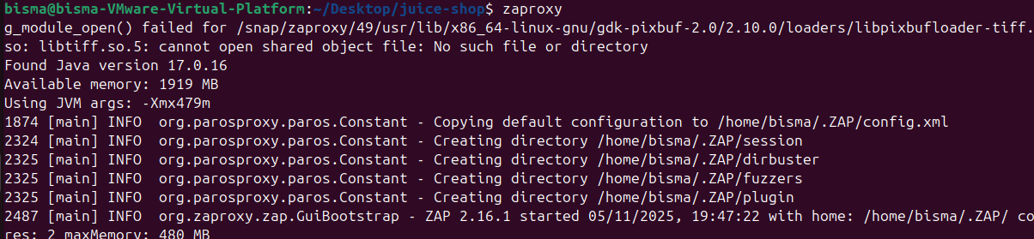
You will see the following screen:
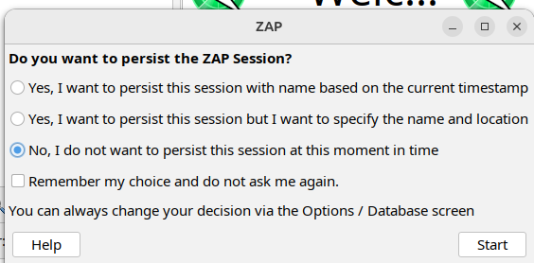
∙ You can select the third option.
∙ Go to Tools -> Options and select Display and mark the option Enable app integration in containers and click OK.
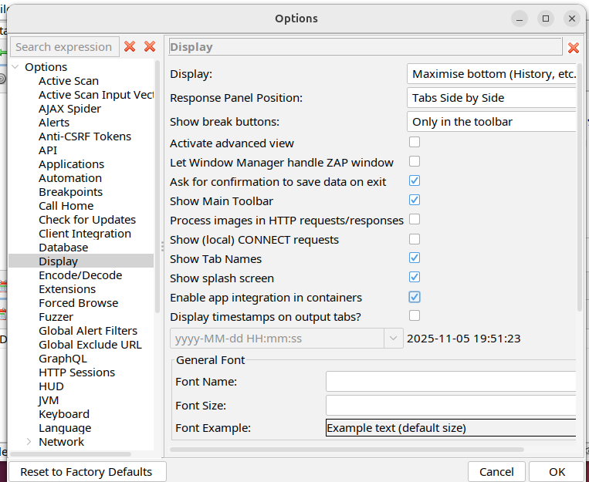

Part 2: Running an Automated Scan
In an automated scan, ZAP passively scans traffic to identify potential vulnerabilities without actively attacking the application.
From the home screen of Zap UI, click Automated Scan. In the URL, add http://localhost:3000/#/ and click Attack.
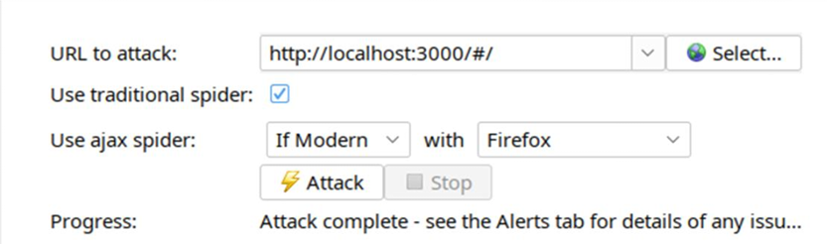
You can click an alert to see details.
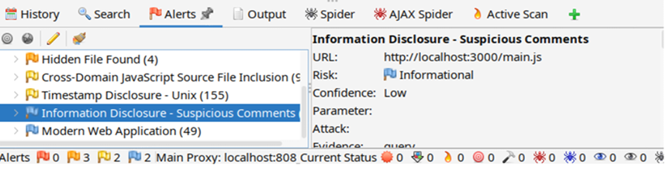
Once the automated attack is complete, you will see the following messages in the browser:

Post-Lab Tasks
∙ Write a brief reflection on how a manual attack differs from automated scans and how it enhances understanding of vulnerabilities.
ZAP Setup Analysis
- Installing via Snap ensures the latest ZAP version along with all required dependencies.
- The --classic flag grants essential system-level access for full functionality.
- Browser integration challenges underscore the complexities of containerized environments.
- Outcome: A robust, enterprise-grade security scanner is successfully deployed and operational.
ZAP Automated Scan Results Analysis
Scan Output Summary:
- Medium Risk Alerts: Typically 5–10 detected per scan
- Low Risk Alerts: Around 15–25 minor issues identified
- Frequent Findings Include:
  - Missing security headers (e.g., X-Content-Type-Options)
  - Cookies lacking Secure and HttpOnly attributes
  - Information leakage via HTTP response headers
  - Absence of anti-CSRF protection mechanisms
Observed Limitations:
- Critical SQL injection vulnerabilities were not flagged by the automated scan.
- Some XSS detections were inaccurate, resulting in false positives.
- Business logic flaws remained undetected due to limited contextual analysis capabilities.

